Hi Sunny –

I would like to try one more approach before we move on from Wix. Although my preference would be to stick with Wix because of the CMS features it provides, I understand that I may not be compatible with what we are trying to do. Ultimately, the need for the charts will dictate the solution we go with.

At some point today while trying to investigate the problem, I decided to turn my attention to pythonanywhere, and began to contemplate the possibility that the problem may reside there. I think the approach of using a designated URL per graph is a really good idea, and I was really confused why the graph would sometimes (and sometimes not) work on desktop, and always not work on mobile.

I’m not 100% sure, but I believe this issue may be caused by the settings in Django. Please see what guided my thinking below.

Just to clarify, I agree that using Wix fetch() is not going to work unless we discover some workaround. I contacted someone with much experience using Wix and he confirmed its problematic going this route. What im describing below relates to the second method of having each chart have its own dedicated url.

1 – Wix iFrame works for <https://williamgorfein.com> for both desktop and mobile previews:

**Desktop version:**

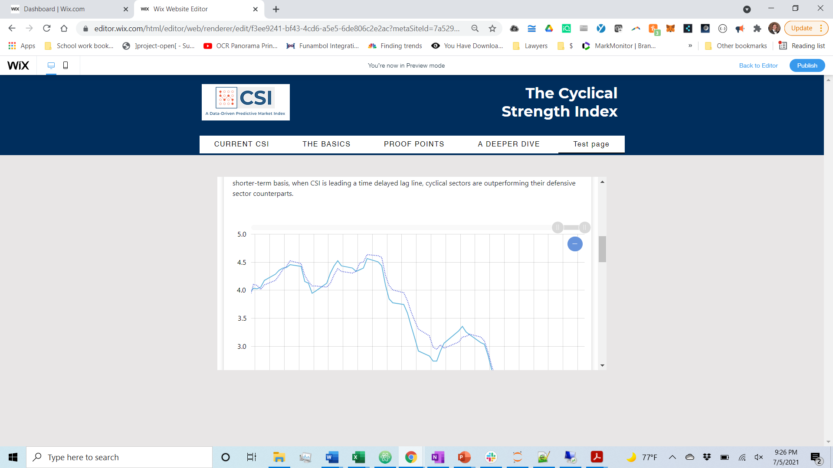

**Mobile version:**

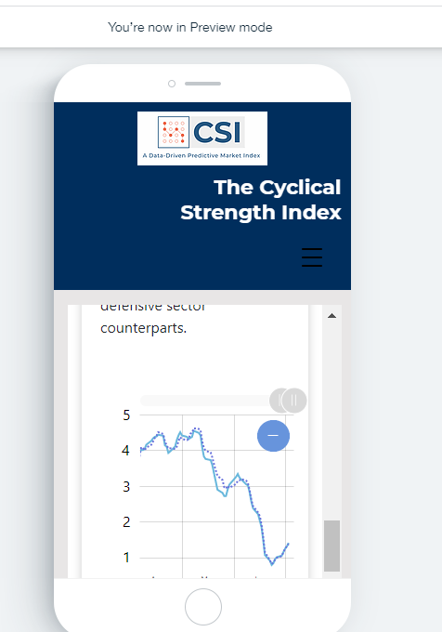

In both versions above (desktop and mobile), both the main site of williamgorfein.com and the amcharts on that site render just fine.

** disclaimer **

I then went to the site on my actual mobile, and although the iframe containing williamgorfein.com loaded fine, the amcharts did not load. HOWEVER, this is a problem I have on my phone anyways when I go to williamgorfein.com – for some reason, the amcharts currently on williamgorfein.com do not work on my phone. I conclude this is an error with the amcharts configuration. This issue has persisted for about a year and the new charts on our pythonanywhere site work just fine on my mobile.

I wanted to point this out in case you try on your mobile and notice the charts do not load – it’s a preexisting problem fyi and I don’t think it relates to our current troubleshooting.

2 – Other weblinks and feedback

<https://www.pythonanywhere.com/forums/topic/12155/>

<https://www.pythonanywhere.com/forums/topic/11581/>

I thought this link may be addressing the problem I am currently having on williamgorfein.com

<https://github.com/amcharts/amcharts3-angular2/issues/12>

(I don’t care to fix this issue fyi, since the goal of the new site is to replace what’s currently on williamgorfein.com)

I thought the discussions on the pythonanywhere forums (along with the iFrames for williamgorfein.com loading) were compelling enough to warrant investigating whether the issue we’re having is related to the configuration on pythonanywhere / Django as opposed to an issue posed by Wix.

Please let me know what you think.